**NAAN MUDALVAN ASSIGNMENT**

**NAME:** VINISHA P

**DEPARTMENT**: BE BIOMEDICAL ENGINEERING

**COLLEGE**: 8151 DHANALAKSHMI SRINIVASAN INSTITUTE OF TECHNOLOGY

**NAANMUDHALVAN COURSE**: DIGITAL MARKETING

**NM ID**: D891B173393C0C08BF4417E7079EFB02

ASSIGNMENT 1:

Create a blog or website using Blogspot and word press. Customize the theme design and post new article with 500 words.

URL: <https://wordpress.com/view/inshagarden.wordpress.com>

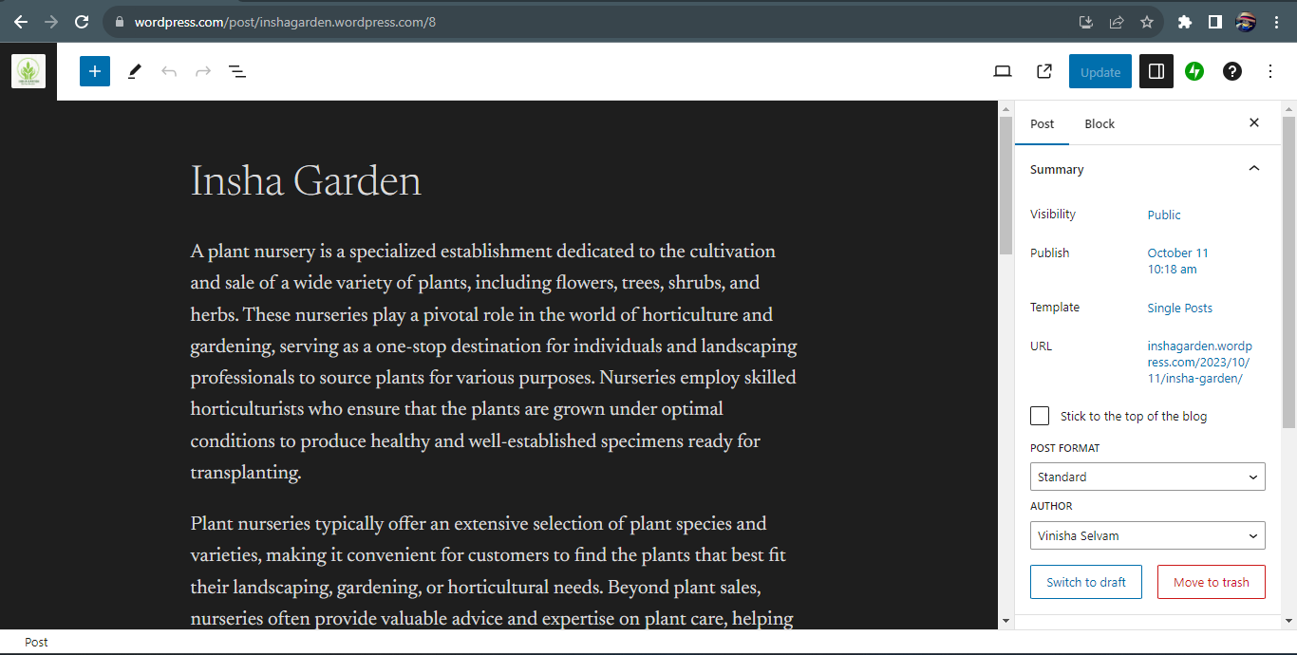

ASSIGNMENT 2:

Create a new Facebook business page and post one social media poster for your brand.

URL: <https://www.facebook.com/inshagardenplantparadise?mibextid=ZbWKwL>

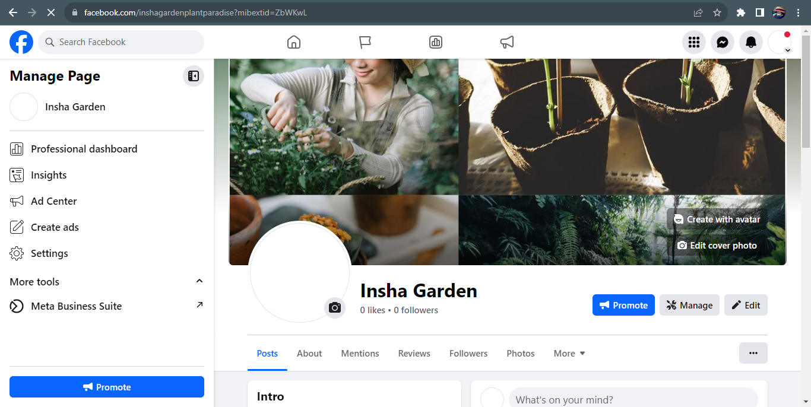

ASSIGNMENT 3:

Create and design a advertisement poster using Canva.

URL: <https://www.facebook.com/photo?fbid=122114665412007248&set=a.122114665442007248>

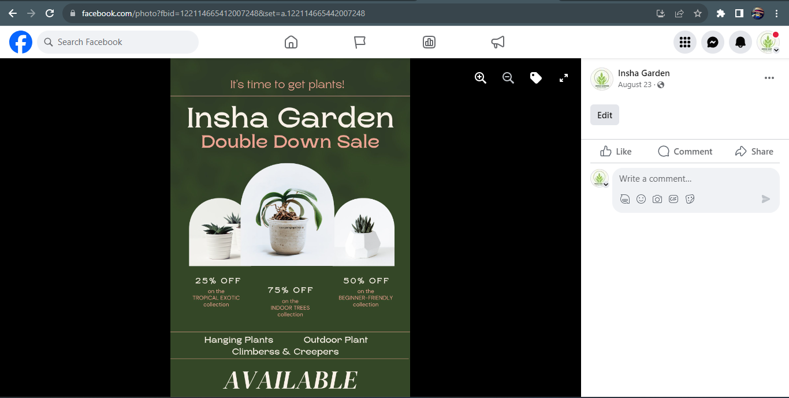

ASSIGNMENT 4:

Create an E mail newsletter design using Mailchimp or Canva tool.

URL: <https://inshagarden.blogspot.com/2023/09/insha-garden-email-newsletter.html>

